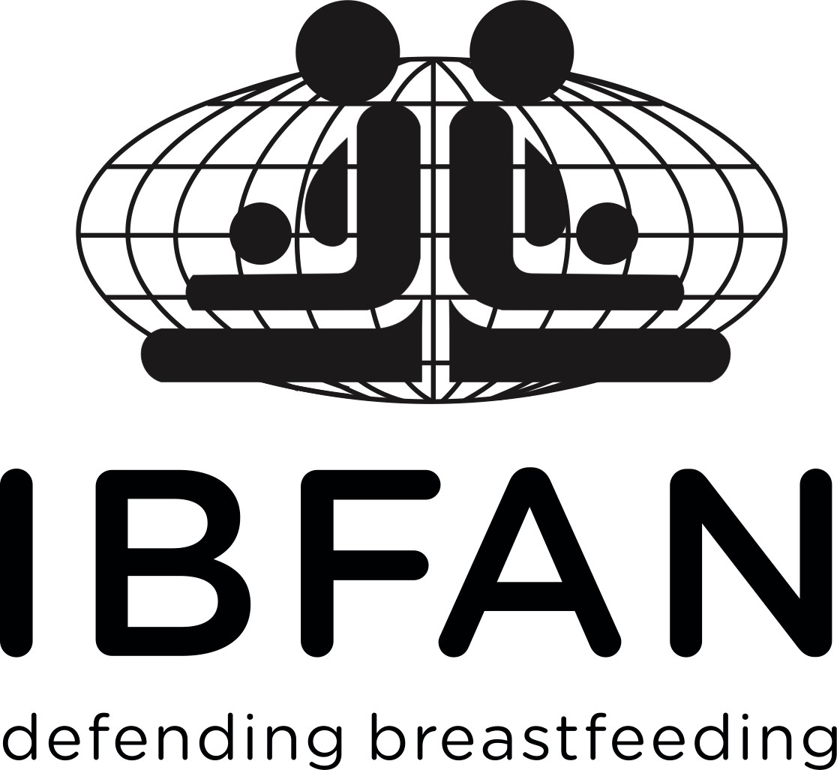
International Baby Food Action Network (IBFAN)

72th session of the World Health Assembly 20-28th May 2019

Agenda Item 11.5 Universal Health Coverage.

As one of WHO’s longest-standing public interest partners, whose primary concern is to protect breastfeeding and child health, IBFAN strongly supports the efforts of Member States to ensure publicly funded UHC, with primary health care and prevention as a foundation.
It is worrying that many governments are now under attack from those pushing privatised systems, who pay no attention to how easily these can sabotage public health goals.
Innovative arrangements that can genuinely advance health are to be welcomed – but they must be carefully screened and monitored by truly independent bodies, without corporate involvement. Public Private Partnerships and Multi-Stakeholder arrangements inevitably lead to private sector involvement in health care planning corporate access to personal data, and most importantly privatisation of services. WHO knows well how easily this can happen, especially in the infant and young child feeding arena.
While WHO cannot police what happens at country level, it does have an obligation to warn Member States of the risks of inappropriate commercial involvement and how to avoid - not just manage - them. Indeed, WHO now seems to fear being seen as ‘risk averse’ more than being seen as cavalier, even negligent. We call on WHO and Member States once again to protect their independence, integrity and trustworthiness and provide Member States with the reliable and independent evidence that shows clearly that public provision of services is the only way to achieve health for all. This issue is a slippery slope that needs to be navigated very carefully and WHO has a key role to play in getting it right.
Lastly, as a priority, Member States, must monitor and ensure full policy and programme support to the protection, promotion and support breastfeeding, including it in the indicators of monitoring SDGs 2/3 and ensuring full implementation of the International Code and Resolutions, maternity protection and universal Baby Friendly Hospital Initiative.

For more information contact:

Patti Rundall, prundall@babymilkaction.org +447786523493
Fédora Bernard, fedora.bernard@gifa.org
Katherine Campbell, kcampb33@kent.edu
Britta Boutry-stadelmann britta.boutry-stadelmann@gifa.org

