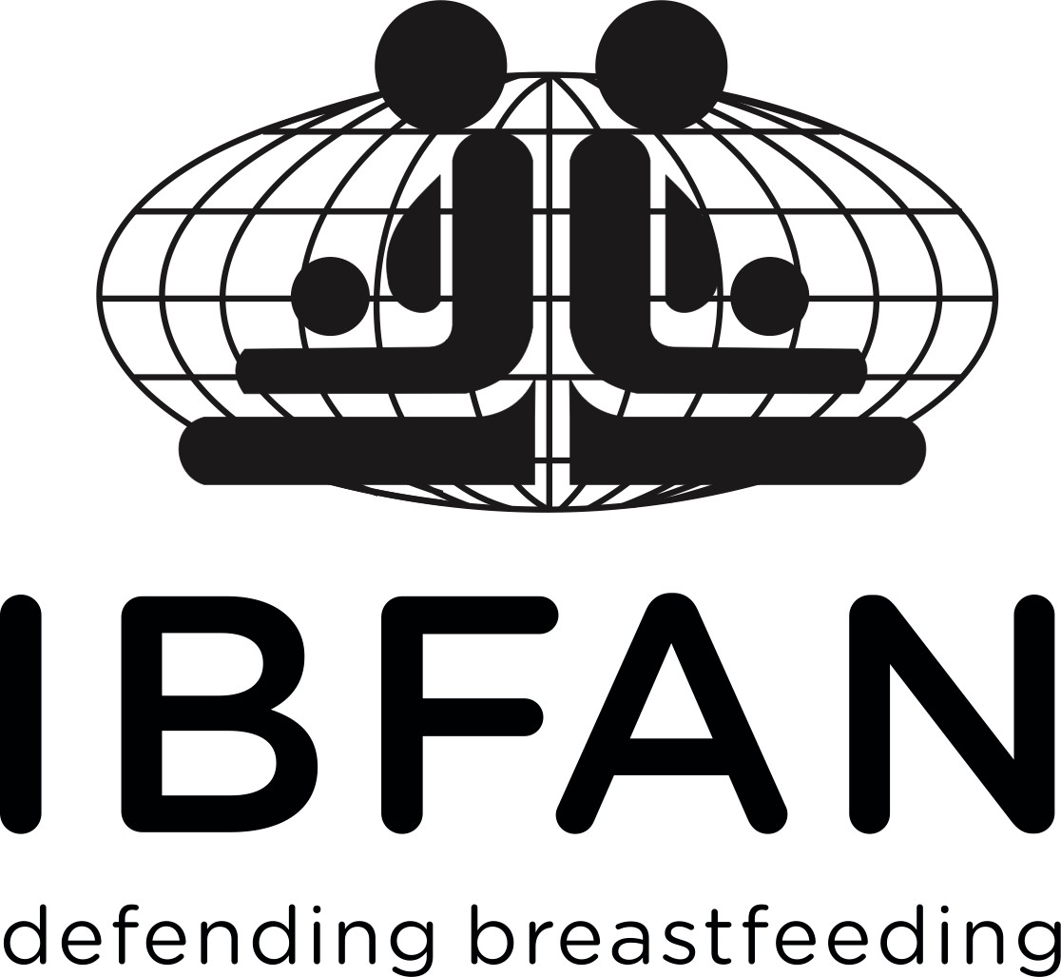
International Baby Food Action Network (IBFAN)

72th session of the World Health Assembly 20-28 May 2019

Agenda Item 11.2 WHO’s work in health emergencies.

As a global network that protects breastfeeding, IBFAN is pleased to comment on this important topic.

Breastfeeding is a lifeline in emergencies. Babies are born with an undeveloped immune system and are at greatest risk of water-related diseases - with diarrhoeal disease the second biggest killer of under-fives. Breastfeeding provides food, care and immune support, and protects them from the worst of emergency conditions.

Despite this, all too often emergency responses are characterized by unsolicited donations of baby feeding products. This does not only put infant health at risk but also hinders women empowerment. Public appeals for funds often make this worse – with starving babies shown alongside the myths used by the baby food industry. Rarely do they highlight the resilience of breastfeeding or that artificially fed babies face many more risks to survival.

IBFAN’s World Breastfeeding Trends Initiative assessments show that implementation of UN recommendations on this is dismal. WHO can play a key role in reversing this situation by promoting the Infant and Young Child Feeding in Emergencies - Operational Guidance for Emergency Relief Staff and Programme Managers, which is designed to give all those working in emergencies guidance on appropriate infant and young child feeding and ensure that when breastmilk substitutes are required they are purchased, distributed and used according to the UN’s agreed strict criteria.
We welcome the IOAC recommendation that WHO establishes long-term relationships with key NGOs on the ground and hope you will guard against COI and we look forward to working with WHO to ensure that families in emergencies have the support and protection they need.
For more information contact:

Patti Rundall, prundall@babymilkaction.org +447786523493
Fédora Bernard, fedora.bernard@gifa.org
Katherine Campbell, kcampb33@kent.edu

