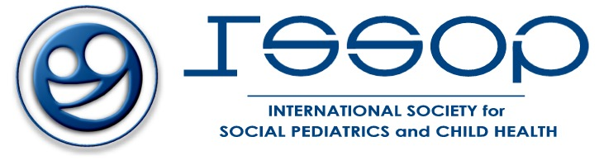
For Immediate Release
July 10, 2018
Contact: Jeffrey Goldhagen, M.D., Jeffrey.Goldhagen@jax.ufl.edu, 1.904.237.9475 (US)
Nicholas Spencer, M.D., N.J.Spencer@warwick.ac.uk, +44.7542.961640 (Europe)

Statement on America’s Opposition to the International Resolution
in Support of Breastmilk Feeding

The International Society of Social Pediatrics and Child Health (ISSOP), in concert with collaborating national and international societies of pediatrics (www.ISSOP.org), condemns in the most robust terms possible American officials’ attempts at the World Health Assembly to stop global collaboration to protect, promote and support breastmilk feeding. Breastmilk feeding is recognized as among the most effective health promoting measures to advance infant and child health. (https://www.issop.org/2008/02/01/essop-position-statement-2/)
In combination with the separation of children from their parents at the US border with Mexico (https://www.issop.org/2018/06/26/issop-response-us-governments-separation-families-violation-child-human-rights/), these policies represent a reprehensible global assault on the health and well-being of infants and children. We call on all public and private sector individuals and organizations to register their concerns with their governments and with the U.S. Government; and for the dismissal of US policy makers connected with these decisions.
We also call on all national and international pediatric organizations and stakeholders in infant health and well-being to review and renew their support for the International Code on Marketing of Breastmilk Substitutes; as well as their policies related to receiving support from formula companies—that inevitably create serious conflicts of interest. (https://www.issop.org/2014/04/24/issop-position-statement-4/)

ISSOP is an interdisciplinary, non-governmental, non-profit making, professional organizational open to all child health professionals. The purpose of the organization is to advance knowledge of social paediatrics and children’s rights, stimulate research, disseminate knowledge, translate knowledge into practice, and work with its members and national and international agencies and organizations to advocate for the global health and well-being of children. Social Pediatrics is a holistic, interdisciplinary, child-rights-based approach to child health. It considers the health of the child within the context of their society, environment, school, and family. Social pediatrics integrates the physical, mental, and social dimensions of child health and development to fulfil children’s rights to optimal health and quality of life.

To learn more about the International Society for Social Pediatrics and Child Health, please visit: https://www.issop.org/

